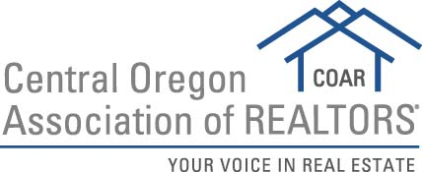

2019 REALTOR® OF THE YEAR NOMINATION FORM
Please submit to kim@coar.com by February 28, 2019

This program is designed to give recognition to REALTORS® who have served not only their profession, but also their communities. The criteria listed below are used as guidelines when selecting our local ROTY. COAR honors one ROTY each calendar year. Service on COAR committees and/or board is highly preferred for candidates.
- REALTOR® Spirit – high principles of integrity, adherence to the REALTOR® Code of Ethics, and furtherance of the principles of good real estate practice among brokers, agents and the general public.
- Civic Activity – Local, state and national level participation in civic and service clubs, charitable activities, political commissions, fraternal or religious groups.
- Business Accomplishments – Public recognition of business conduct, service to clients, imaginative and creative advertising programs, rehabilitation work, land utilization, etc.
- Local Association/Board Activity – Offices held and committee work, special assignments, seminar activity and educational work, membership and offices held in local chapters of Institutes, Societies and Councils.
- State Association Activity – Offices held and committee work, attendance and participation in state conventions, directors meetings and educational conferences.
- National Association Activity – National offices and committee work, membership and work in Institutes, Societies and Councils, attendance at national conventions and directors’ meetings.

Nominee Name:

Nominee Office:
Years in the Business:
COAR Experience/Participation:
OAR and/or NAR Experience/Participation:
Business Accomplishments:
Civic/Community Activities:
REALTOR Spirit:
Why do you think your nominee is qualified other than the above:

Nomination submitted by:

Date:

